Created on Thu Dec 12 01:22:13 2019

##########################################################Basic

1 - Install the Python 3.7 Language on your computer:

- Instructions for Linux: If using Linux (Ubuntu), you probably don't need to install it as most distributions have it by default. Here are the instructions if you still need to for some reason: https://realpython.com/installing-python/#linux

- Instructions for Mac: https://realpython.com/installing-python/#macos-mac-os-x . If you prefer to do it "from scratch" you can use this guide : https://www.python.org/downloads/ but it requires more OS technical knowledge.

- Instructions for Windows: I strongly recommend using Anaconda (a Data Science Platform that already has Python installed) from : https://www.anaconda.com/distribution/. If you prefer to do it "from scratch" you can use this guide : https://realpython.com/installing-python/#windows but it requires more OS technical knowledge.

2 - Install PyCharm Community Edition on your computer, this will be our main editor to work with Python for now and it's available for all operating systems: https://www.jetbrains.com/pycharm/download/

Feel free to open the tool and explore it a bit, but next class we'll dedicate some time to get familiar with it.

Send me a message confirming the installations through slack

'''

## Basic: I have already done it earlier during the course

'''

###########################################################Advanced

1 - Complete the Software Carpentry Linux/Bash lessons 1 to 4. This will review what we learned today and adds a few commands to it. Link : https://swcarpentry.github.io/shell-novice/

2- Send me what this command do: cat <file> | head -n 3 | sort

## ######################### Implementation

1: done

2: Send me what this command do: cat <file> | head -n 3 | sort

Create a new text file with the below contents by using vi



|  |  |  |
| --- | --- | --- |
| 1 | Guy | Gilbert |
| 2 | Kevin | Brown |
| 3 | Roberto | Tamburello |
| 4 | Rob | Walters |
| 5 | Rob | Walters |
| 6 | Thierry | D'Hers |
| 7 | David | Bradley |
| 8 | David | Bradley |
| 9 | JoLynn | Dobney |
| 10 | Ruth | Ellerbrock |
| 11 | Gail | Erickson |
| 12 | Barry | Johnson |
| 13 | Jossef | Goldberg |
| 14 | Terri | Duffy |
| 15 | Sidney | Higa |
| 16 | Taylor | Maxwell |
| 17 | Jeffrey | Ford |
| 18 | Jo | Brown |
| 19 | Doris | Hartwig |
| 20 | John | Campbell |

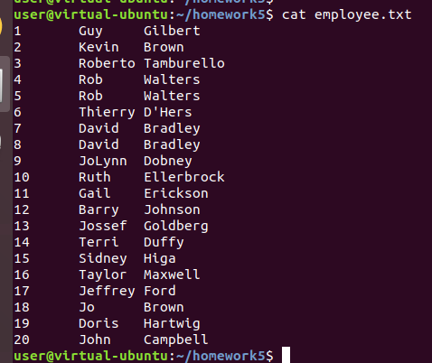

cat <file> | head -n 3 | sort :

* cat: used to view the content of the employee file
* | is linux pipe command used to direct the output of one comman to another
* head uniitlit provide my deafult the first 10 rows from the file
* -n 3 options for head just to read the first 3 rows
* sort command is uswed for sort the file by line

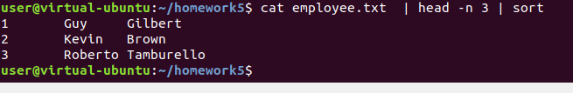

Just want to highlight that I have my certification from CompTIA Linux+ (Powered by LPI)

And I’m using Oracle Enterprise Linux and Oracle Sun Solaris for the last 10 years